AI ASSISTED CODING
HALLTICKET NO: 2403A52400
BATCH NUMBER :14
Lab assignment-1.1
Prompt 1: Factorial without Functions
Use GitHub Copilot to generate a Python program that calculates the
factorial of a number without defining any functions (using loops
directly in the main code)
Code(screenshot):
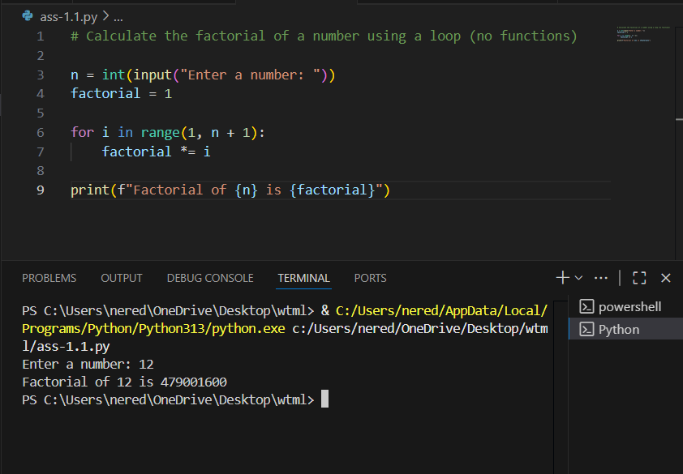
Code explanation:
This code calculates the factorial of a user-provided number using a loop:
- It prompts the user to enter a number and stores it in n.
- It initializes factorial to 1.
- It uses a for loop from 1 to n, multiplying factorial by each number in the range.
- After the loop, it prints the result, which is the factorial of the input number.

Prompt 2: Improving Efficiency
• Description:
Examine the Copilot-generated code from Task 1 and demonstrate
how its efficiency can be improved (e.g., removing unnecessary
variables, optimizing loops).

Code(screen shot):
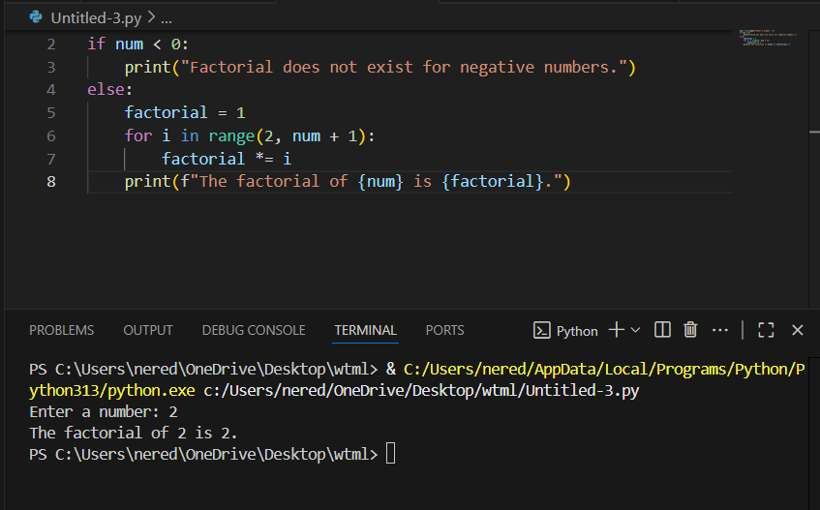
Code explanation:
This code calculates the factorial of a number entered by the user:
- num = int(input("Enter a number: "))
Prompts the user to enter a number and converts the input to an integer.
- if num < 0:
Checks if the number is negative.
- print("Factorial does not exist for negative numbers.")
If negative, prints a message since factorials are only defined for non-negative integers.
- else:
If the number is zero or positive:
  - factorial = 1
Initializes the factorial result to 1.
  - for i in range(2, num + 1):
Loops from 2 up to and including num.
    - factorial *= i
Multiplies factorial by each value of i in the loop.
  - print(f"The factorial of {num} is {factorial}.")
Prints the final factorial value

prompt 3: Factorial with Functions
Use GitHub Copilot to generate a Python program that calculates the
factorial of a number using a user-defined function.

Code(screen shot):
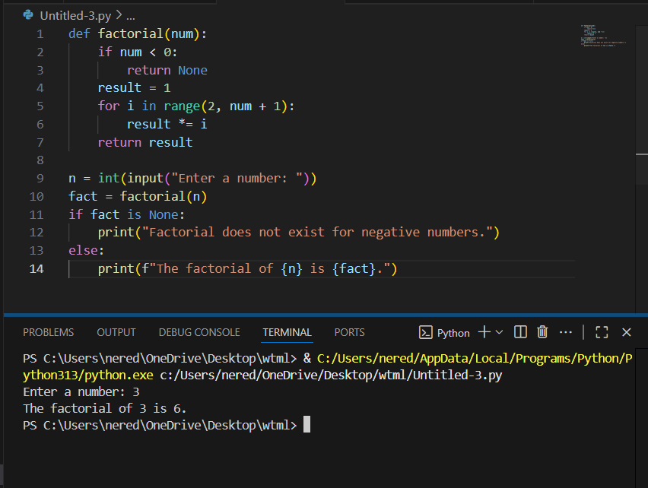
Code explanation:
This program calculates the factorial of a number using a user-defined function:
- The factorial(num) function checks if the input is negative. If so, it returns None.
- If the input is zero or positive, it initializes result to 1 and multiplies it by each integer from 2 up to num.
- The main code gets a number from the user, calls the factorial function, and stores the result.
- If the result is None, it prints a message for negative numbers. Otherwise, it prints the factorial value.
Prompt 4: Comparative Analysis – With vs Without Functions
Differentiate between the Copilot-generated factorial program with functions and without functions in terms of logic, reusability, and execution

Code(screen shot):
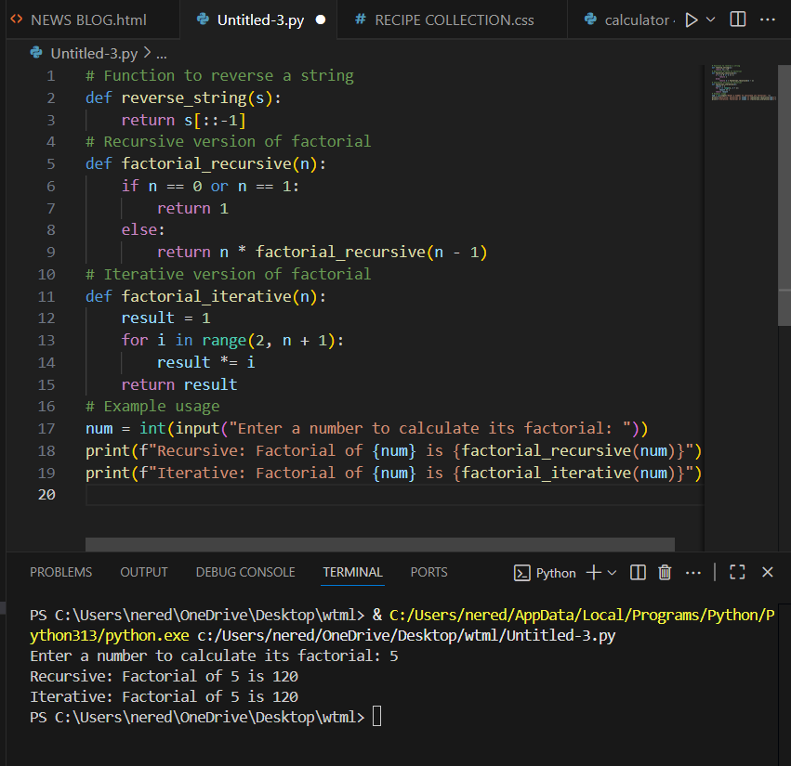

Code explanation:
- reverse_string(s):
This function takes a string s and returns its reverse using slicing (s[::-1]).
- factorial_recursive(n):
This function calculates the factorial of n recursively.
  - If n is 0 or 1, it returns 1 (base case).
  - Otherwise, it returns n * factorial_recursive(n - 1).
- factorial_iterative(n):
This function calculates the factorial of n using a loop.
  - It initializes result to 1.
  - Then multiplies result by each number from 2 to n.
- Example usage:
  - The user is prompted to enter a number.
  - The program prints the factorial of that number using both the recursive and iterative functions.
Prompt 5:Iterative vs Recursive Factorial
● Description:
Prompt GitHub Copilot to generate both iterative and recursive versions of the factorial function.
● Expected Output:
o Two correct implementations.
o A documented comparison of logic, performance, and execution flow between iterative and recursive approaches.

Code (screen shot):
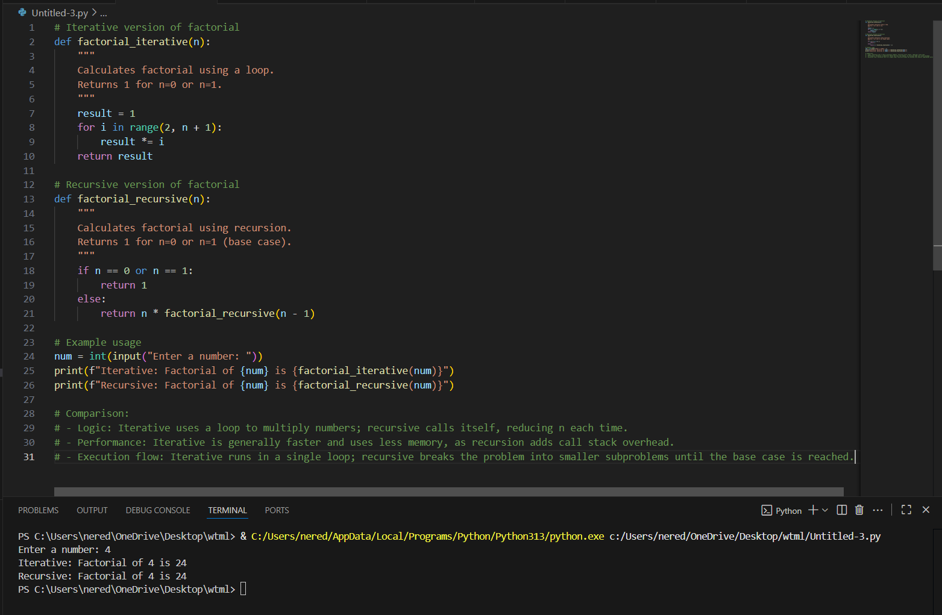
Code explanation:
The code provides two ways to calculate the factorial of a number:
- Iterative Version (factorial_iterative)
  - Uses a loop to multiply numbers from 2 up to n.
  - Returns 1 for n = 0 or n = 1.
  - Efficient in terms of speed and memory.
- Recursive Version (factorial_recursive)
  - Calls itself with n - 1 until it reaches the base case (n = 0 or n = 1).
  - Returns 1 for the base case.
  - Less efficient for large n due to call stack overhead.
Example usage:
- Prompts the user for a number.
- Prints the factorial using both methods.
Comparison:
- Logic: Iterative uses a loop; recursive breaks the problem into smaller subproblems.
- Performance: Iterative is faster and uses less memory.
- Execution flow: Iterative runs in a single loop; recursive uses multiple function calls until the base case.

